**Department for People**

**Supporting People**

Housing related support

**Comments, Complaints & Compliments**

September 2013

**Service User Panel approved**



**You can ask for help with this leaflet from your support worker/provider, Citizens Advice Bureau, an Advocate or the Supporting People team.**



😐 **Comments**



We like to hear what you think about where you live and the support you have



Your ideas can help us improve services and help others



Tell us if the support you get is good or if you think something should be changed

**OR**

☺ **Compliments**



We like to know if you are happy with your personal support and where you live.



We like to hear if you are happy with your support provider.



We like to know that everything is OK



We like to know if you are pleased with the work of the Supporting People Team

☹ **Complaints**



Making a complaint means speaking about something you do not like or something that you are not happy with.

Making a complaint can be a good way of making things change for the better.



It is ok to complain. You can complain about anything to do with your support service. We need to know what is wrong with your service so we can try to make the service better.

If you make a complaint you are **not** at risk of losing your tenancy which is a worry for some people.

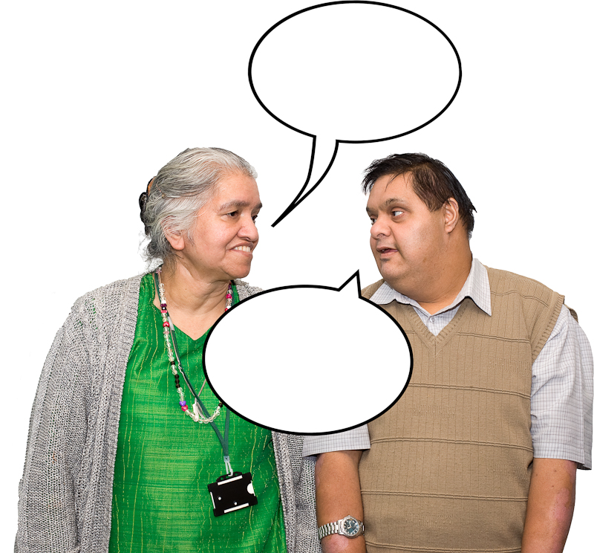

**What is a complaint?**

It is when you are not happy with:

1. The way you are treated
2. The standard of service you get from your support provider

For example:-

My support worker keeps changing our appointments

OR

I have reported a dripping tap three times and nothing has been done.



**What is NOT a complaint?**

A complaint is not a general question, comment or issue about your service.

For example:-

My Support worker called me to tell me they had to change my appointment

OR

My tap is dripping

Some things only become a complaint if nothing is done about them.

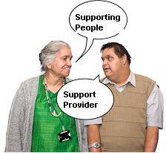

**Who should I complain to?**

First you should complain to the person or the organisation that provides you with support. They will have their own complaints policy and will be able to explain it to you and help you make the complaint if you ask them.

If you complained to your support provider, but were not happy with the result you may speak to us. We can then investigate your complaint with your permission. We will ask you to sign a consent form. This will give us permission to speak with your support provider, and to see any documents relating to your complaint.

If you would prefer not to speak to your support provider about your complaint, you may complain directly to the Supporting People Team.



**If you make a complaint to Supporting People we will: -**

* Write to say we got your complaint within 5 working days.
* Listen and take your complaint seriously.
* Make sure we understand what the problem is.
* Write to tell you what will be done about your complaint within 10 working days.
* If it is more complex and we need to speak with a number of people we will keep you informed.

If we have looked at your complaint and you are still unhappy with our response you can take your complaint to the Supporting People Lead Officer. Write to them at the Department for People address on page 8.

After you have been through the Supporting People and Adult & Community Services Complaints process if you are still unhappy you can contact the Local Government Ombudsman. The Ombudsman will not normally look at a complaint until it has been through the local authority’s complaints process. If you wish to contact them directly you can:



Write to:

Local Government Ombudsman

PO Box 4771

Coventry, CV4 0EH

Phone: 0300 601 614 OR

0845 602 1983



Text: text ‘call back’ to 0762 480 4299



E-mail: [advice@lgo.org.uk](mailto:advice@lgo.org.uk)

**Can someone complain for me?**

Yes, if you have given them written permission to do so, or if you would like support to make your complaint you can have someone with you, such as a friend, relative or advocate.

**Getting In Touch**

To tell us your comment, compliment or complaint, please fill in the attached form and send it back to us or phone or email us, our contact details are below:

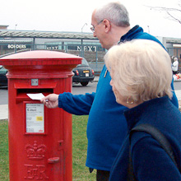

By post:

Supporting People Team

Department for People

Southend-on-Sea Borough Council

PO box 6, Civic Centre

Victoria Avenue

Southend-on-Sea

Essex SS2 6ER



By email: [supportingpeople@southend.gov.uk](mailto:supportingpeople@southend.gov.uk)



By phone: 01702 215474



You can find out more about Supporting People on Southend Borough Council website: [www.southend.gov.uk/supportingpeople](http://www.southend.gov.uk/supportingpeople)

**Supporting People Complaints, Comments and Compliments Form**

Please read this leaflet before completing the form. Use extra sheets if there is not enough space on the form for your complaint.

1. Name
2. Address

1. Post code
2. Tel. No Home

Work

1. Your complaint, Comment or compliment

1. Have you told your support provider about your complaint?

Yes No

Please send this form to:

Supporting People Team, PO Box 6, Civic Centre,

Victoria Avenue, Southend-on-Sea, Essex, SS2 6ER

1. What do you think Supporting People should do to put matters right.

1. If you have any documents you would like to include as part of your complaint please attach copies and tick this box

Signed: Date:

**Making a comment, complaint or compliment**

Do you need any of the following to make your comment, compliment or complaint?



Sign Language / interpreter



Braille



Large print

**Other Useful Contacts**

**Citizens Advice Bureau**

The Citizens Advice Bureau can give you advice about your rights. They can also tell you about advocacies that could help you to make your complaint.



Citizens Advice Bureau

1 Church Road

Southend-on-Sea

Essex SS1 2AL

01702 610610

[www.southendcab.org.uk](http://www.southendcab.org.uk)

**Southend Association of Voluntary Services (SAVS)**

SAVS can provide information about support services in Southend.



SAVS Centre

29 – 31 Alexander Street

Southend-on-Sea

 Essex SS1 1BW

01702 356000



info@savs-southend.co.uk

**A summary of this publication can be provided in alternative formats such as Braille, audio-tape or in large print.**

**Translations of this document in alternative languages are also available. Please call** **01702 215008 ext. 4600.**

Nёse dёshironi njё kopje tё kёsaj fletushke nё gjuhёn tuaj amtare, ose nёse doni tё nё kontaktoni, ju lutemi telefononi nё numrin e poshtё-shёnuar. Ne do tё pёrdorim njё pёrkthyes pёr mes telefonit tё ndihmojmё me kёrkesёn tuaj.

Zkrácená verze této publikace je k dostání i v alternativních formátech, konkrétně v Braillu, na audiokazetě a tištěná veklým typem písma, které je snadno čitelné. Tento dokument byl přeložen i do dalších jazyků a tyto překlady jsou vám také k dospozici.

Lolugwalo luyatholakala njalo lunciphisiwe ngalezi indlela; ngombhalo weziphofu (Braille), kasethi (audio tape), loba lulotshwe ngamabala amakhulu. Luyatholakala njalo lolugwalo lulotshwe ngezihlobo ezitshiyeneyo.

Streszczenie tej publikacji jest dostępne w innych formach, takich jak pismo Braille’a, taśmy audio lub w dużym druku. Dostępne są także przekłady tego dokumentu na inne języki

Um resumo desta publicação pode ser fornecida em formatos alternativos tais como Braille, cassete áudio ou em impressão de letras grandes. Também temos disponíveis traduções deste documento em outros idiomas.



Leaflet Reference Number: 0030