Shared Lives Southend



Service User Guide
(For Service Users living with Shared Lives Carers)



You may need help to understand this booklet.

This guide will tell you about Shared Lives.

It will tell you about the Shared Lives Southend.



If you have any questions

or you want more information about Shared Lives

please contact

Jennie Andrews or Alex George

Shared Lives Southend

CTPLD
Civic Centre
Victoria Avenue

Southend on Sea

Essex SS2 6ER

 01702 534282 or 01702 534293

Shared Lives Southend

Shared Lives can offer somewhere to live with help and support.

Shared Lives can offer somewhere to stay for a short break.



Equal Opportunities

We make sure that:

• we treat everyone fairly

• everyone gets the help they need

What is Shared Lives?

- Shared Lives can be somewhere to live



- Shared Lives can be somewhere to stay for a short break

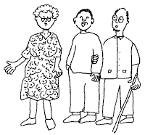

- Shared Lives Southend helps people find a new home, living with Shared Lives Carers.

Carers

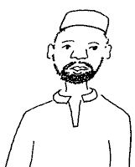 Some carers live alone

 Some carers live with a partner

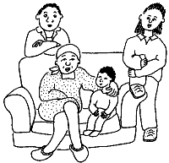 Some carers live with their children

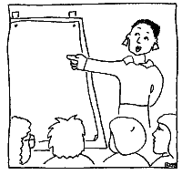

All our Shared Lives Carers have been trained.

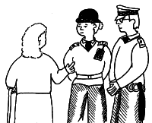

All our Shared Lives Carers have had police checks.

Finding the right Shared Lives Carer


We will tell you about Shared Lives Carers you could live with.

You will get all the help you need.

 ✓
We will help you find a Shared Lives Carer to suit you

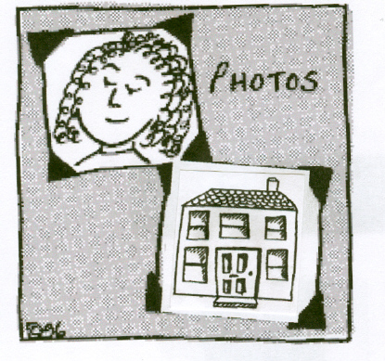
We can show you photographs of the Carers and their home



You will be able to meet the Carers.

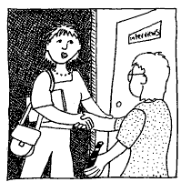 You can visit them a few times so that you can get to know each other.

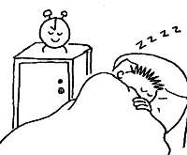 You can sleep there once or twice.

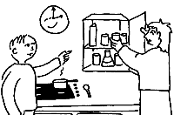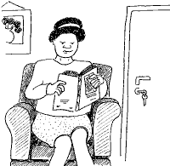

Then you can try living with the Carers.

✓
✓

Living there will help to know if it is OK for the Carers and you

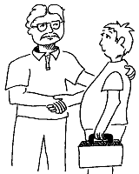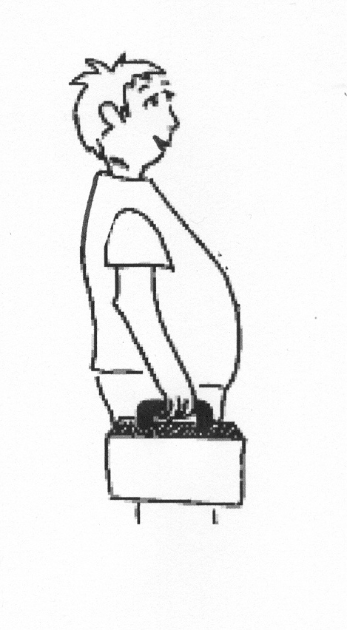

If the Carers agree you can move into your new home.

We will help you move.

Service User Plan



We will help you write a Service User Plan.

The Service User Plan will tell the Carers all about you.

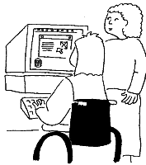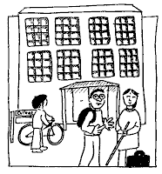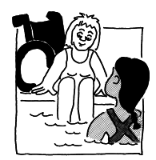

It will show carers what you do in the daytime

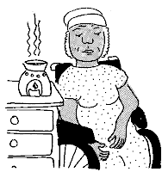

It will show carers what you like to do in the evenings


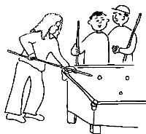

It will show carers what you like to do at weekends




Your Plan will say what new things you would like to do and learn

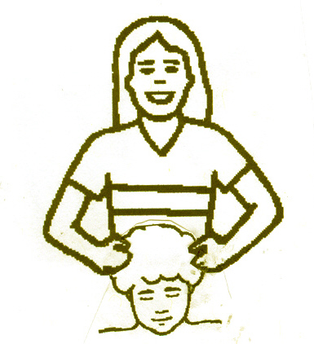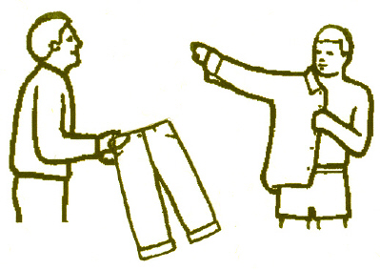

Your Plan will say what help you need to look after yourself



Your Plan will say what help you need to do things you want to do

In your new home



When you are in your new home we will have meetings

The meetings are for you and your Carers

We will ask if you are happy.

☺
We will ask if your Carers are happy.



We will ask if anything needs to change

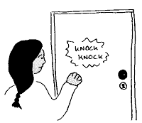

In your new home you will be treated with respect

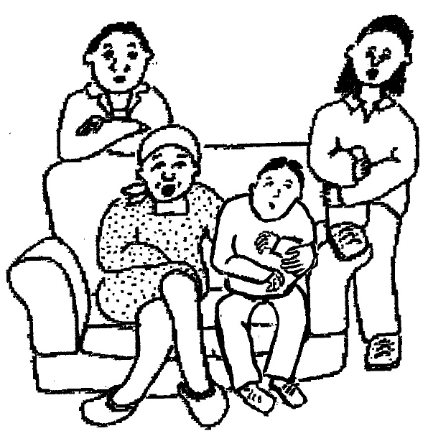

In your new home you will be treated like a member of the family


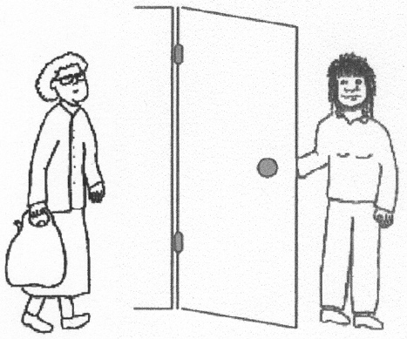

You must respect people who live with you.

Placement Agreement



You will have a Placement Agreement.

You Your carers


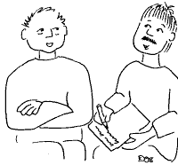

Your Social Worker Your Shared Lives Scheme

The Placement Agreement will show what everyone will do
In your Shared Lives family home

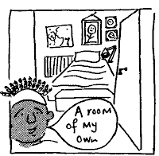

You can have your own room and put your own things in it



Your friends and family can visit you

You can go to see your friends and family

Your Carers will be happy to go out with you to do the things you like



You will be able to go on holiday


Money

Your carers will get money each week to help pay for your placement

You will also give some money to help pay for where you live


This will come out of your benefits

We will tell you how much to pay

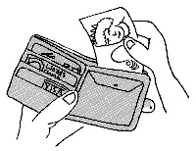

You will have money left to buy things for yourself and to do things

Your carers can help you with things like

managing your money

 making a cup of tea

 making a phone call

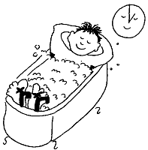 having a bath

Your carers can help you with things like

 taking your medicine or tablets

getting dressed

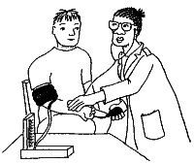 going to the doctors

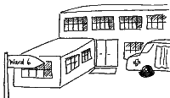 going to hospital



Things your carers know about you are private

They will only share the things they know with other people

- to get help you need

or

- to keep you safe



If you are not happy about your Shared Lives placement

talk to your carers

talk to your Social Worker or Shared Lives Carer

If you are still not happy

 You can make a complaint

You can move out of your placement into another Placement.

You can move on to different accommodation.

Your Social Worker or Shared Lives Carer can contact someone to help you



If you want to know more about Shared Lives

You can ask your Social Worker

Name………………………………………………………….

…………………………………………………………..

You can ask your Shared Lives Carer

Name………………………………………………………….

…………………………………………………………..

 We will be pleased to help you

