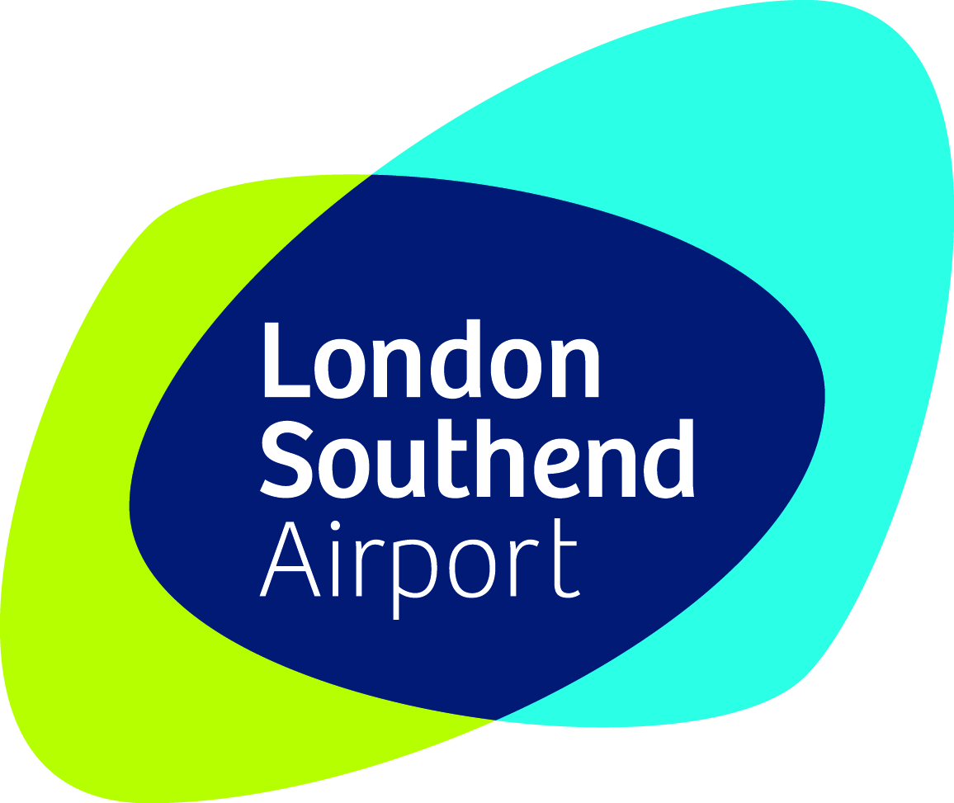




London Southend Airport - Operational Controls Summary Table

Annual Operational Air Transport Movement (“ATM”)Limits
- Total Annual ATM limit of 53,300 excluding “Exempt” ATMs
- Annual Cargo ATM limit of lesser of 5,330 or 10% of total ATMs
- Annual Boeing 737-300 Aircraft ATM limit of 2,150

Night Flight Controls (2300hrs – 0630hrs)
- Night Flight Quota of 120 ATMs per month
- No aircraft with Quota Count (“QC”) of more than 1.0 (EPNDB 92.9) or any helicopters allowed to take off or land in the night period^{1 & 2}
- No Passenger Flights to take off or land between 2300 and 0630 unless they are Delayed or Diverted, provided that up to 90 Passenger Flights per month may be scheduled to land during the shoulder period of 2300 and 2330hrs
- If the number of ATMs at night exceed 120 there are provisions for compensatory adjustments in the Night Flight Quota for the following Quota Month.

Daytime Noise Restrictions (0630 – 2300hrs)
- No aircraft with QC of more than 2.0 (EPNDB 95.9) allowed to take off or land, provided that up to 60 daytime movements of aircraft with a QC between 2 and 4.0 (EPNDB 95.9 - 98.9) undergoing maintenance are allowed in each Quota Year
- If the number of ATMs of aircraft of between QC2 and QC4 exceed 60 in a Quota Year there are provisions for compensatory adjustments in the Quota for the following Quota Year.

Take-off and Landing Procedures
Night Time (2300hrs – 0630hrs):
- All aircraft will take off towards and land from the north-east unless prevented from doing so for safety reasons.
Day Time (0630hrs – 2300hrs):
- All aircraft will take off towards and land from the north east where movement volumes and safety requirements allow
- Departing Aircraft shall follow the defined south-westerly and north-easterly Noise Preferential Routes
- Fewer than 50% of landings in daytime to be from the south-west
- Fewer than 50% of all landing and departures in daytime to be over the south-west when assessed annually

Air Quality Noise and Track Monitoring by the Airport Company
- Operate an Air Quality Monitoring Programme and Carbon and Environmental Management Plan
- Maintain Noise and Track Keeping System (including 2 fixed and 1 mobile noise monitors) and produce annual reports
- Maintain a Noise Complaints Service
- Instrument Landing System and Secondary Radar shall be installed and maintained

Monthly and Three Monthly Reports by the Airport Company
- Number of ATMs, cargo ATMs, Boeing 737-300 ATMs
- Number of Night Flights including Diverted, Delayed and Exempt from night quota limits
- Flights that did not follow the north easterly take off and landing preference

Ground Noise
- Quiet Ground Operations Scheme
- Best Practice Plan for Aircraft Engine Testing
- Engine Tests only permitted at the following times:
- 0800 to 2000 Monday to Friday
- 0800 to 1800 on Saturday
- 0900 to 1800 on Sunday

Penalties
- Fining of airlines if they consistently fail to comply with the take off, landing, track keeping procedures or ground noise restrictions

Property Purchase, Noise Insulation, and Vortex schemes operated by the Airport Company
- Property Purchase Scheme offered to properties within 69dBA LAeq contour
- Sound and Thermal Insulation Grants offered to residential properties, schools and hospitals within 63dBA LAeq contour
- Repairs to any roofs damaged by wake vortex turbulence

ATM means any rotary or fixed wing aircraft carrying out air traffic movements comprised of taking off or landing at the Airport. Each take off is one ATM and each landing is one ATM.
Excludes certain prescribed aircraft movements namely “Delayed ATMs”, “Diverted ATMs” or “Exempt ATMs” which have a QC of 1 or less and are approved by the Airport Consultative Committee. “Exempt” includes movements by police, military, air ambulance, organ transplant and official government flights. Compliance assessed annually not monthly. Delayed ATMs, Diverted ATMs and Exempt ATMs with a QC of 1 or more shall count towards the Quota of 120 per month, those with QC less than 1 shall not count towards the Quota.
Passenger Flights means any ATM by a commercial passenger aircraft carrying passengers whether scheduled or unscheduled and excludes a) movements by aircraft carrying no passengers (e.g. for repositioning or maintenance) and b) movements by business jets or other business aircraft subject to private air charter.
Any such flights must have a QC of 1 or less and will be included in the 120 monthly night flight quota limit
Excludes “Diverted” or “Exempt” ATMs
Excludes aircraft with a Maximum Certificated Weight of 5.7 tonnes or less

